University of Engineering and Technology, Lahore
Name: Maria Abbas
Reg No: 2026(S) CYS_61
Department: Computer Engineering
Degree: Cyber security
Section: B
Assignment: PF Lab week 10
Date: 18 May 2026
CLO2

Lab Tasks
Recursion
Task 1:
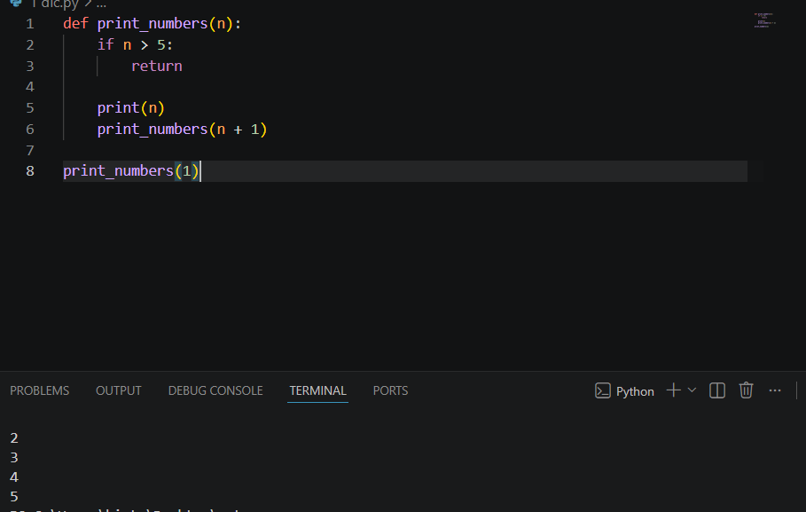

Task 2:
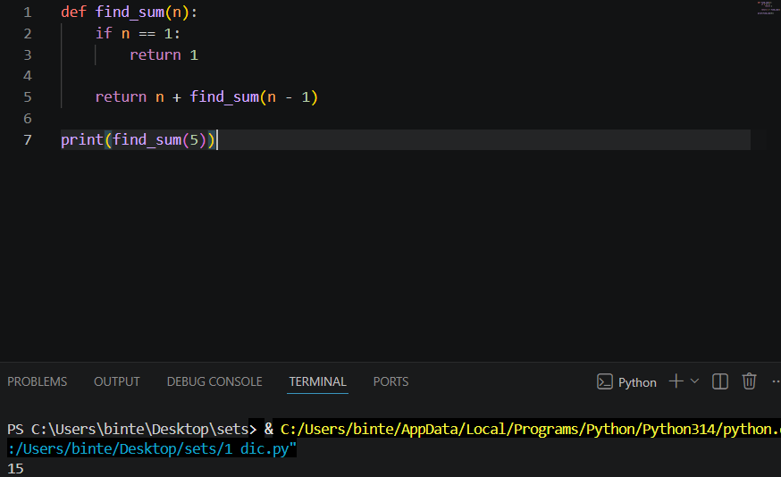
Task 3:
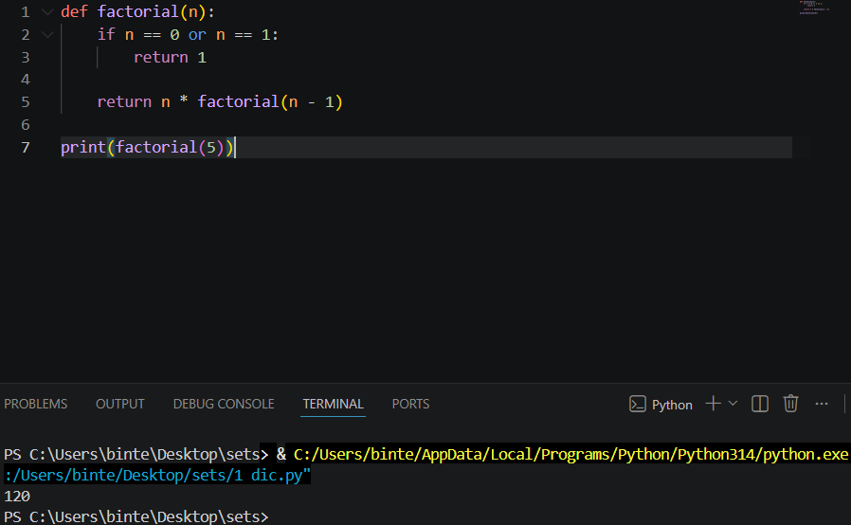
Task 4:
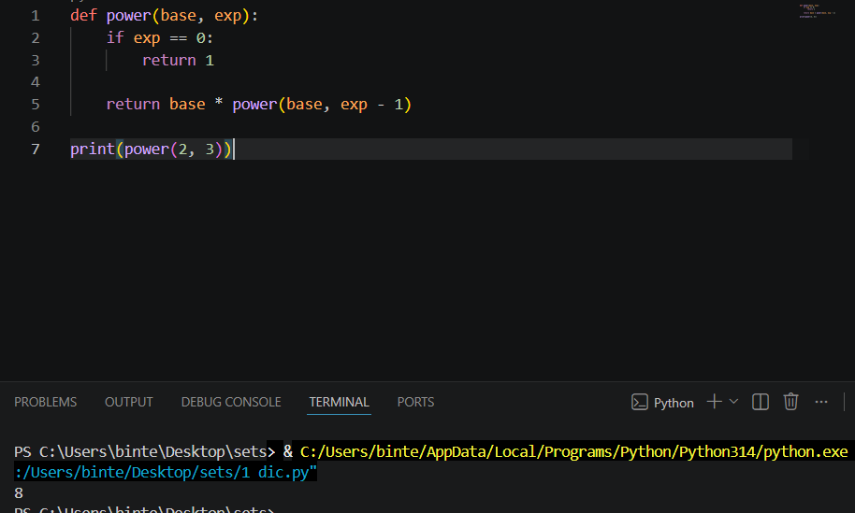
Task 5:
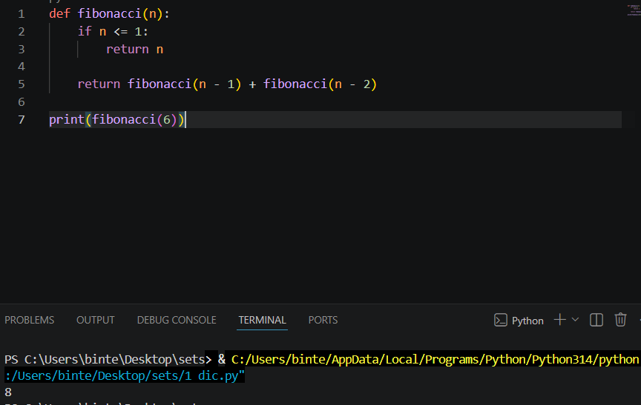
Task 6:
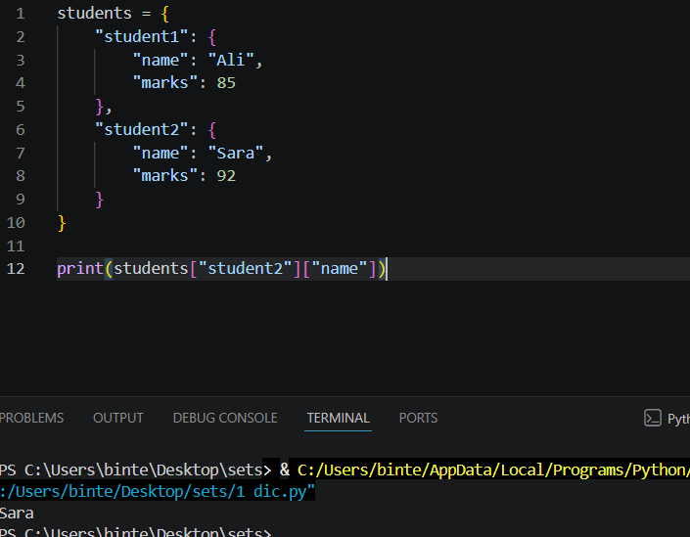
Task 7:
